Accessibility Features on Mac
From www.support.apple.com 4/2024
On Mac, choose Apple Menu > System Preferences, then click Accessibility.

Vision
VoiceOver User Guide
Change Zoom preferences for accessibility
Use Hover Text
Zoom in on the Touch Bar
Change Display preferences for accessibility
Change Pointer preferences for accessibility
Change Color Filters preferences for accessibility
Change Spoken Content preferences for accessibility
Change Descriptions preferences for accessibility

Hearing
Real-Time Text (RTT)
macOS accessibility features for hearing
Change Audio preferences for accessibility
Change RTT preferences for accessibility
Change Captions preferences for accessibility

Motor
macOS accessibility features for mobility
Control your Mac and apps using Voice Control
Create a custom vocabulary
Use item number and grid overlays
Navigate your Mac using Full Keyboard Access
Change Keyboard Hardware preferences for accessibility
Use the Accessibility Keyboard
Control the pointer using Dwell
Change Mouse & Trackpad preferences for accessibility
Control the pointer using Mouse Keys
Change Alternate Control Methods preferences for accessibility
Move the mouse using head pointer
Use Switch Control

General:
macOS general accessibility features
Siri requests
Change Siri preferences for accessibility
Change Shortcut preferences for accessibility

Use the Accessibility Shortcuts panel on Mac
The Accessibility Shortcuts panel offers shortcuts to quickly turn on or turn off common accessibility features such as Zoom, VoiceOver, and Sticky Keys.
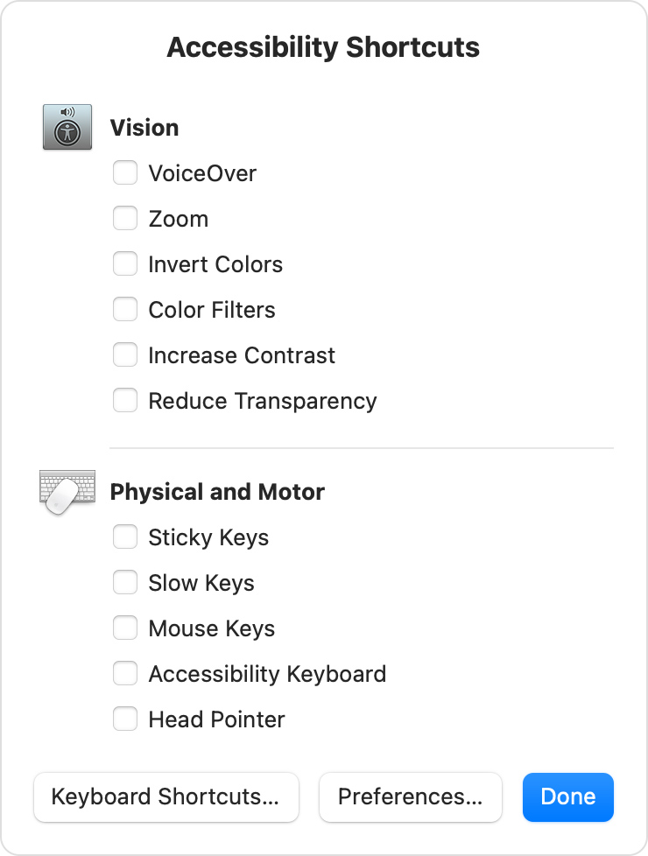

Open the Accessibility Shortcuts panel
Press these keys together: Option (⌥), Command (⌘), and F5. On notebook computers with a Touch Bar, you might need to press the Fn (Function) key as well.
On notebook computers with Touch ID, triple-press Touch ID. (If you press and hold the Command key while doing this, VoiceOver turns on or off.)
To close the panel, click Done or click anywhere outside of the window.

Change the shortcuts in Accessibility Shortcuts
To change the shortcuts that appear in the panel, choose Apple menu > System Preferences, then click Accessibility. Select Shortcut in the sidebar, then use the checkboxes to turn shortcuts on or off.

