Ally Help Sheet for Students
Ally for students is an accessibility tool that can convert and download pages or documents within your Canvas course into alternative formats. Pages and documents that can be converted, will have the icon below next to it.
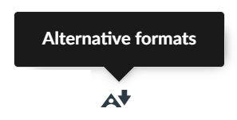
The icon will appear in Canvas like this:

When the icon is clicked, a menu will appear which will list the options for available formats to convert to and download.
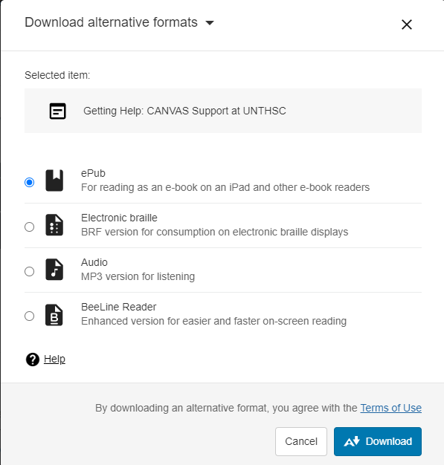
Choose the format desired.
- ePub: For reading as an e-book on an iPad or other e-book reader.
- Electronic braille: BRF version for use with an electronic braille display.
- Audio: MP3 version for listening.
- BeeLine Reader: Enhanced version for easier and faster on-screen reading.
Once you click Download, the Ally converter generates the page or document in the format you chose, and downloads it when it finishes.
Be aware that this is a machine-generated converter so it may not have accurately converted all the content.

