How to Create Quick Check Questions in Canvas

- Click the “edit” button in the top right corner.
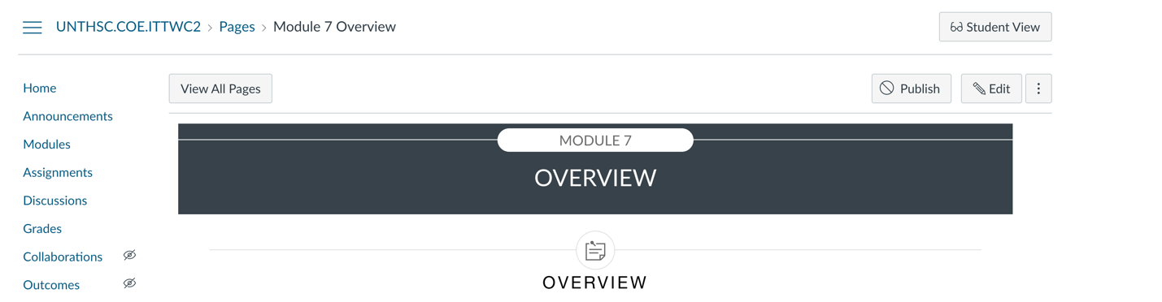

- Click the Designs Tool Icon in the top right corner of the screen.

- Once the right panel opens, select “Add Advance Elements.”

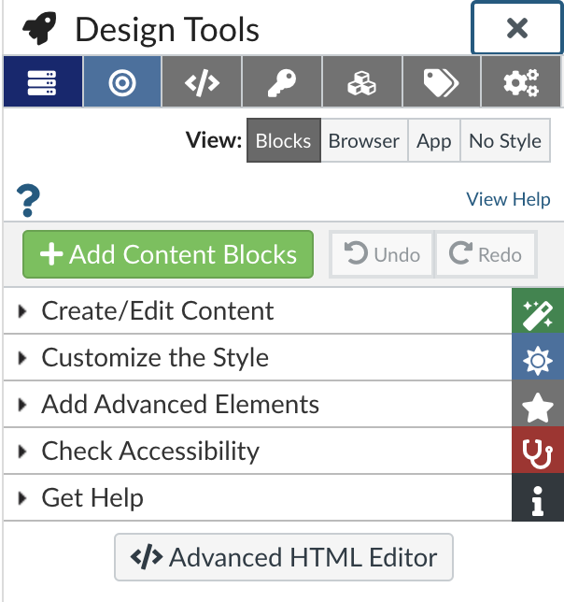

- Next, scroll down to the bottom and select “Quick Check.”
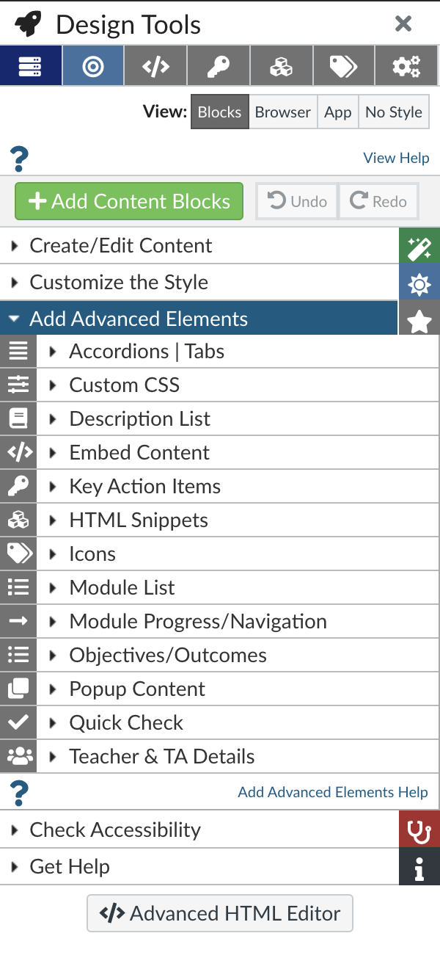

- Next, if you want to add the quick checks in a separate section Click “add as block.” If you want to add the quick checks to a current section, click “add at cursor.”
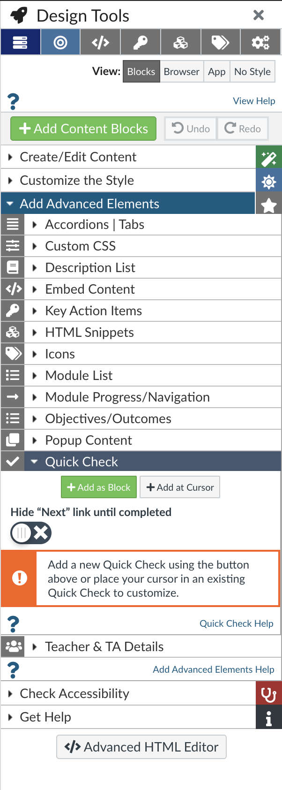

- Once you click the options in the right panel, the quick check template should populate in the section where the cursor is located.
- On the quick check template, in the “Put question here” section, add your practice question.
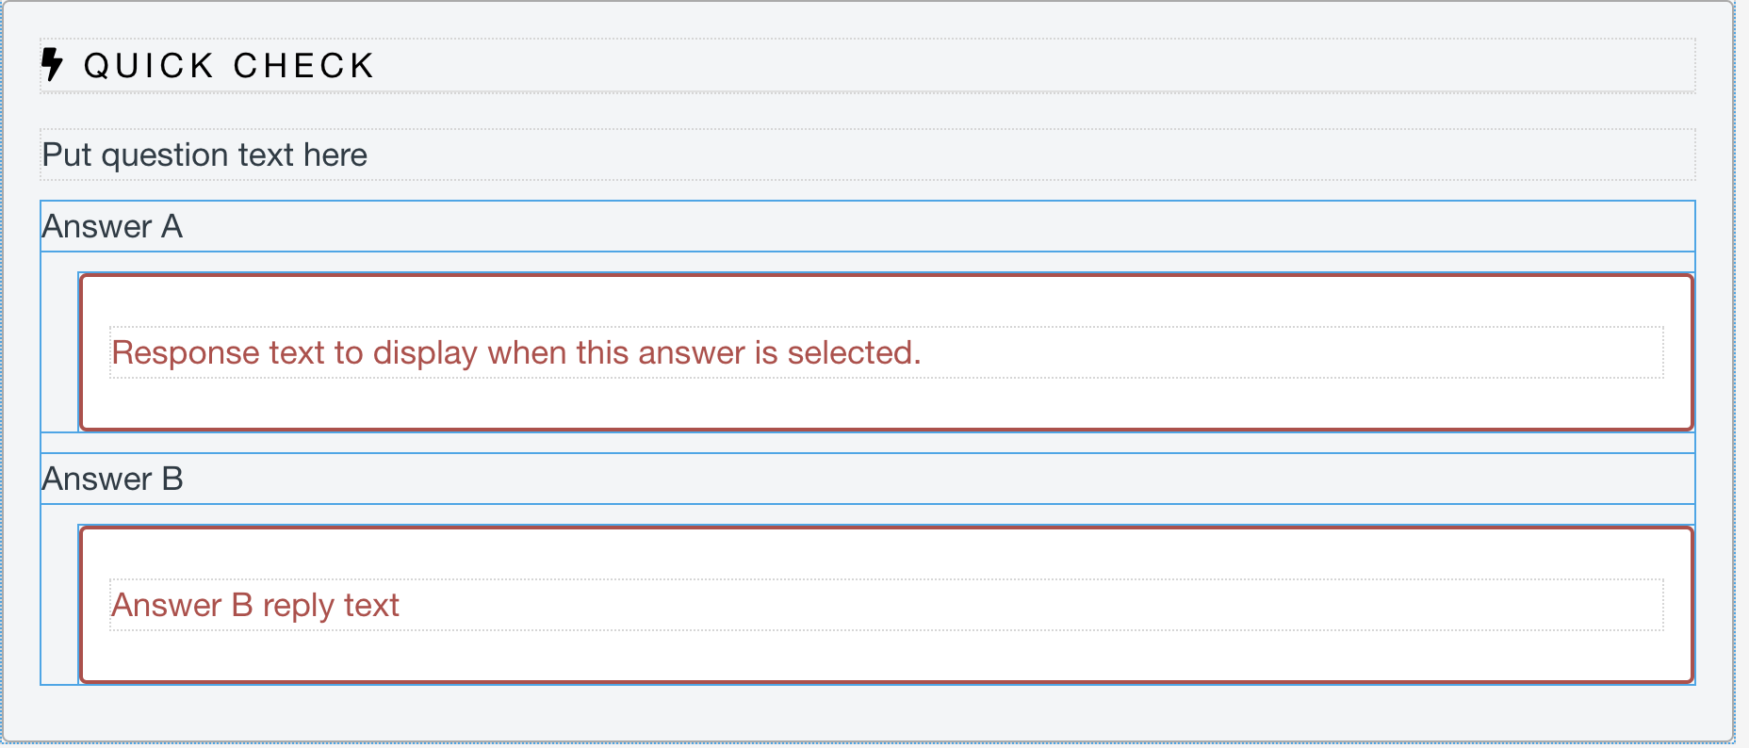

- In the Design Tools right chart panel click in the “Answer A and Answer B box to add your answers.
- If you need to add more answers choices, click “Add answer.”
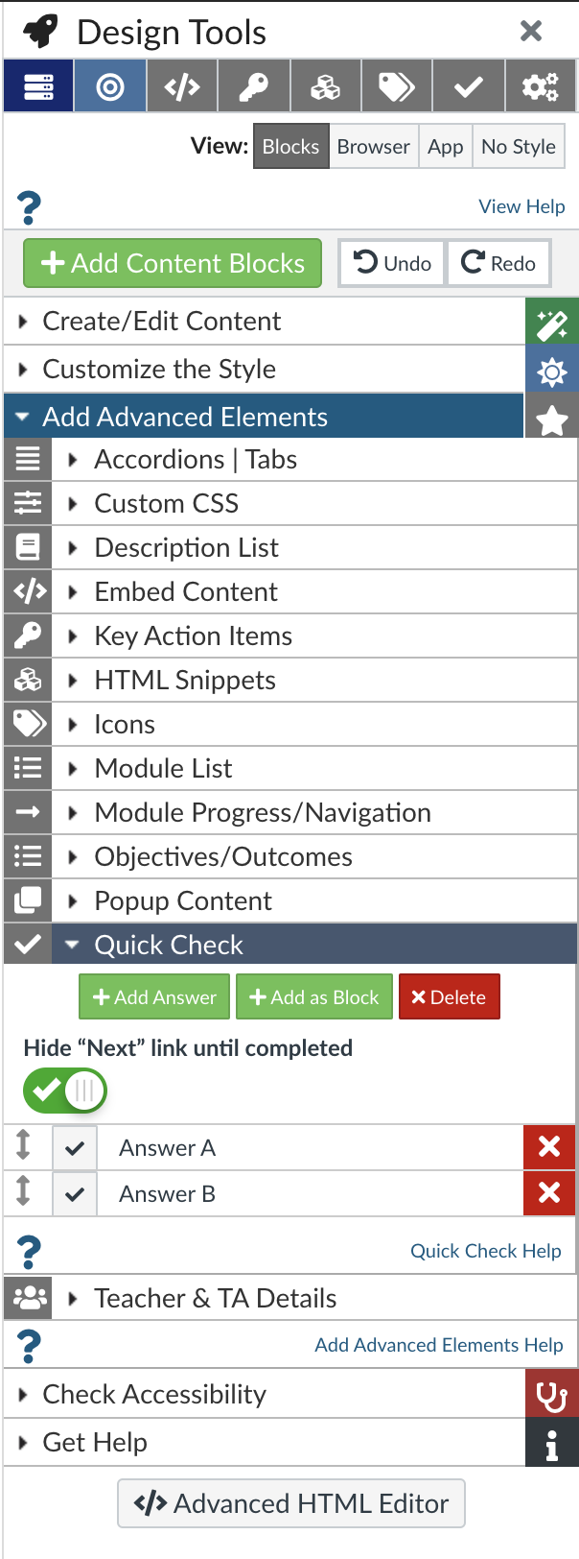

- Once all the quick checks have been completed, at the bottom of the page click “Save.”

