Recording a Lecture in Zoom

1. Open your document or PowerPoint that will be the focus of your lecture.

2. Download the Zoom software to your computer. (Link to Download)

3. Open the zoom software. Be sure to select “login with SSO” rather than logging in with a user ID and password on the login screen. The Login with SSO will take you to a new screen to login with your UNTHSC EUID and password.
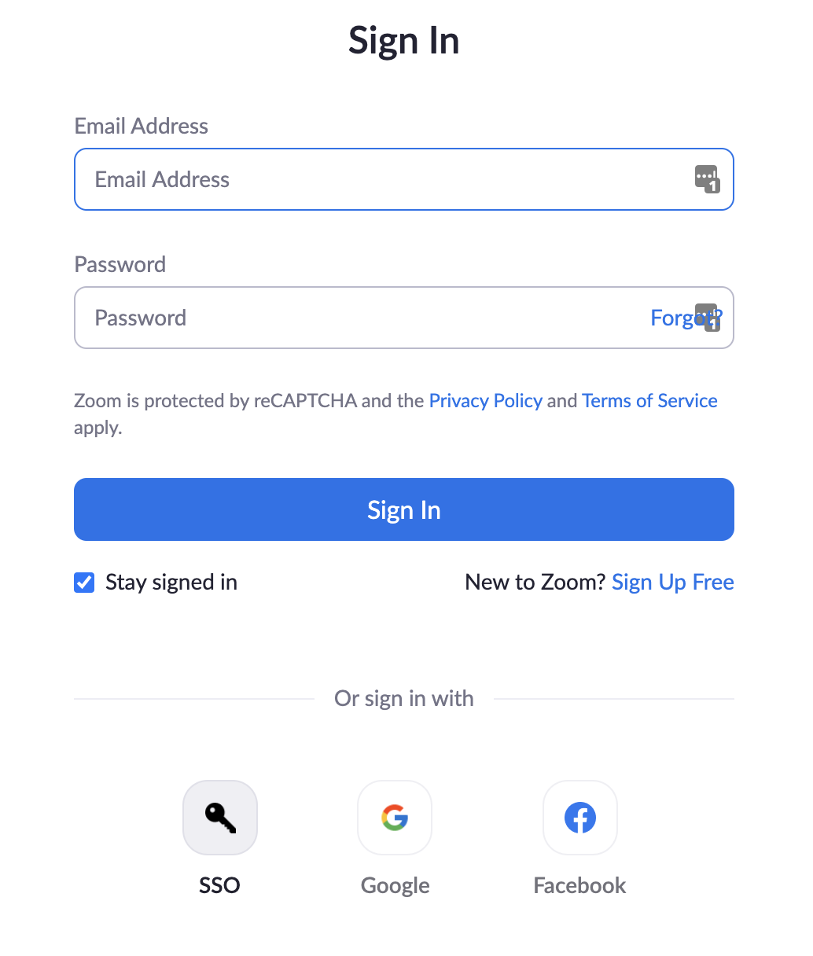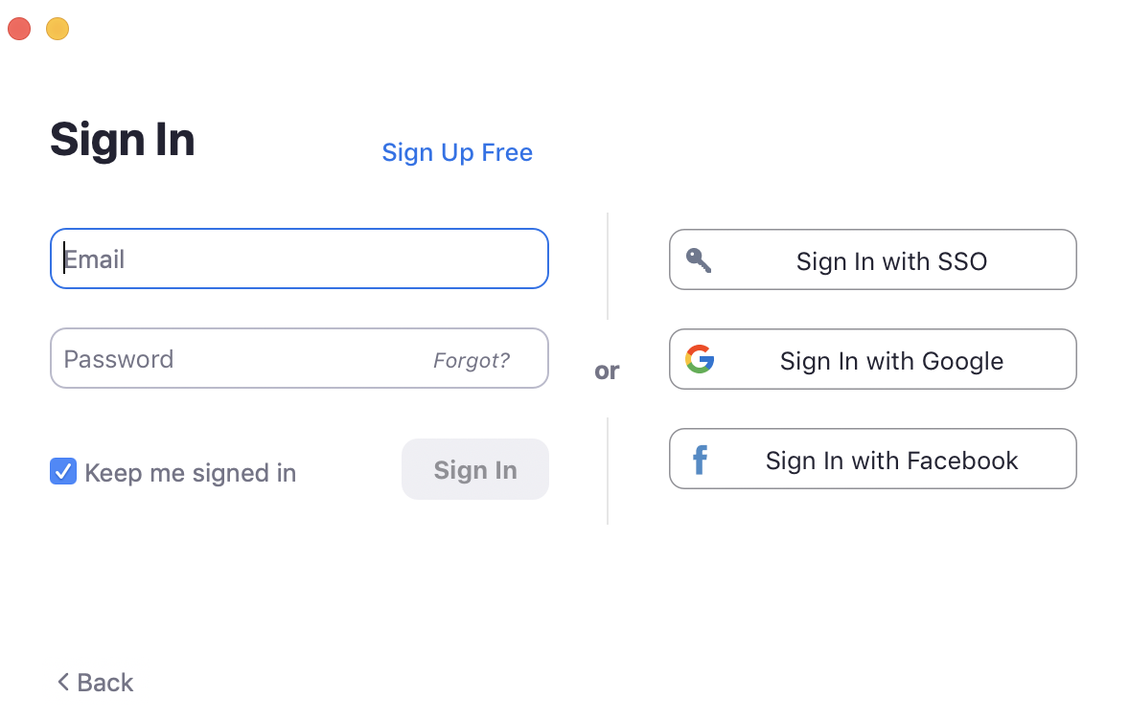
OR

And if it asks for your company domain, it’s unthsc.

4. Start a New Meeting

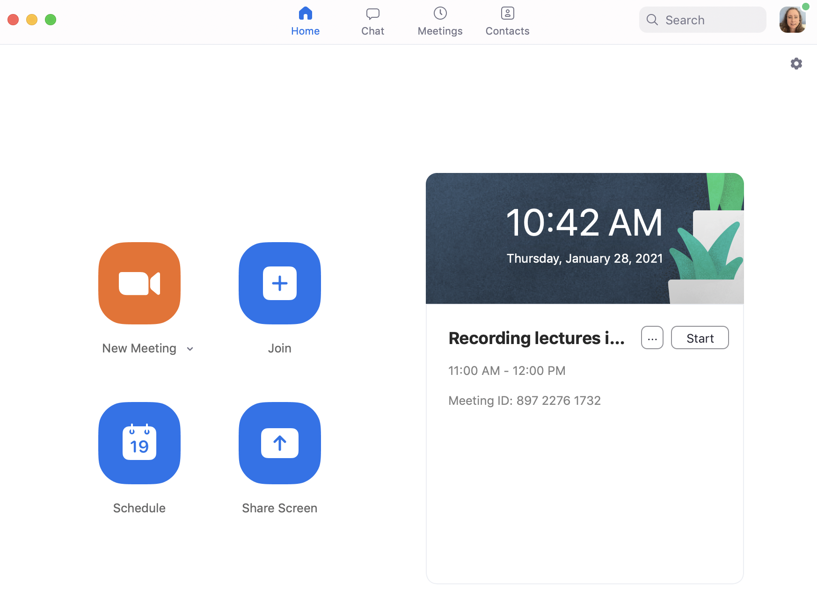

5. Join the computer audio when it prompts you. Be sure to ‘unmute’ yourself.

6. Learners prefer that you also share your camera so that they can see you.

7. Select Share Screen so that your audience can see your PowerPoint presentation or other teaching documents.
Select to share audio
Select to optimize screen share video clip

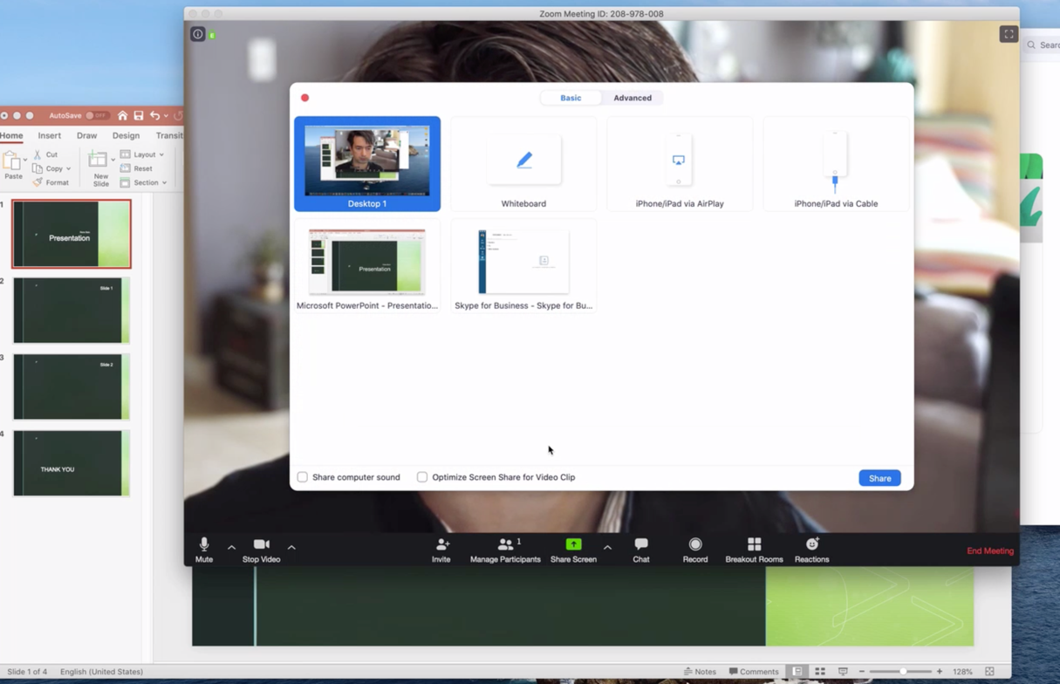
3
2
1

8. Click the icon to start the PowerPoint presentation if that’s what you’re using. If using another type of document, be sure to make the details large enough to see.
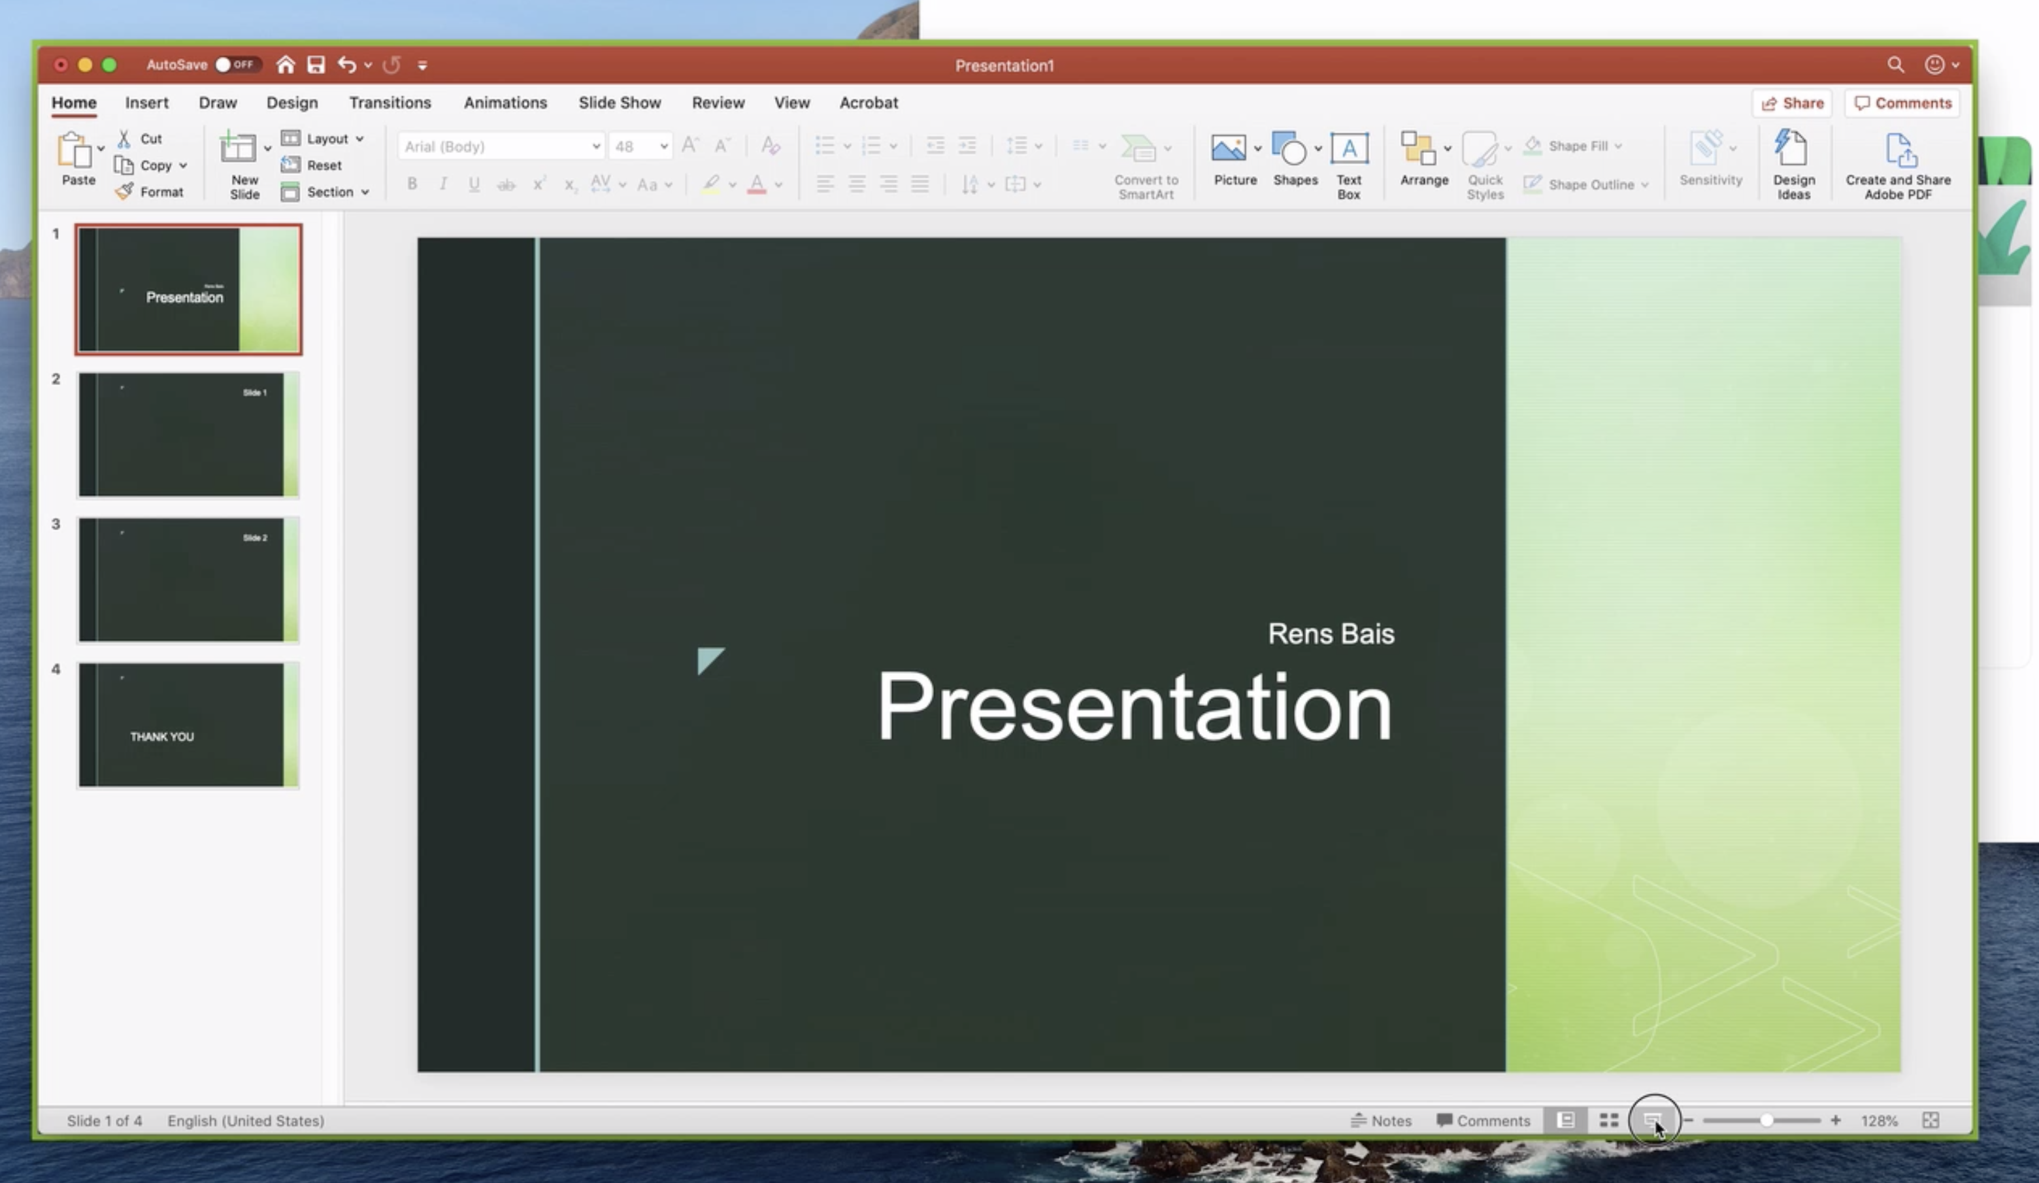

9. The toolbar for zoom at the top of the page has an option for ‘more’. When you click ‘more’, the dropdown has the ‘record’ option. Clicking record will trigger a popup window to ask you if you want to record to your computer or to the cloud.
- If you will be the one putting your video into Mediasite for student viewing, choose to record to your computer.
- If someone else will be putting your video in Mediasite for student viewing, choose to record to the cloud.

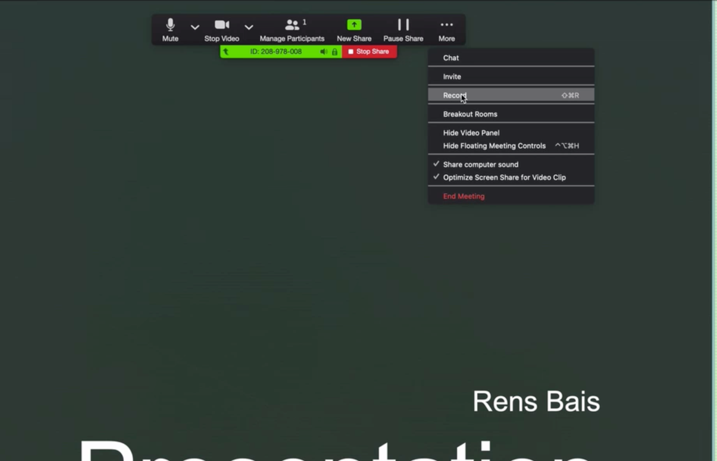

10. Record your presentation.
- You can ‘pause Recording’ to take a break
- Be sure that your recording does not go beyond an hour. It’s best to break sessions up into smaller chunks of information of approximately 20-30 minutes.

11. When your session is complete, select stop recording.
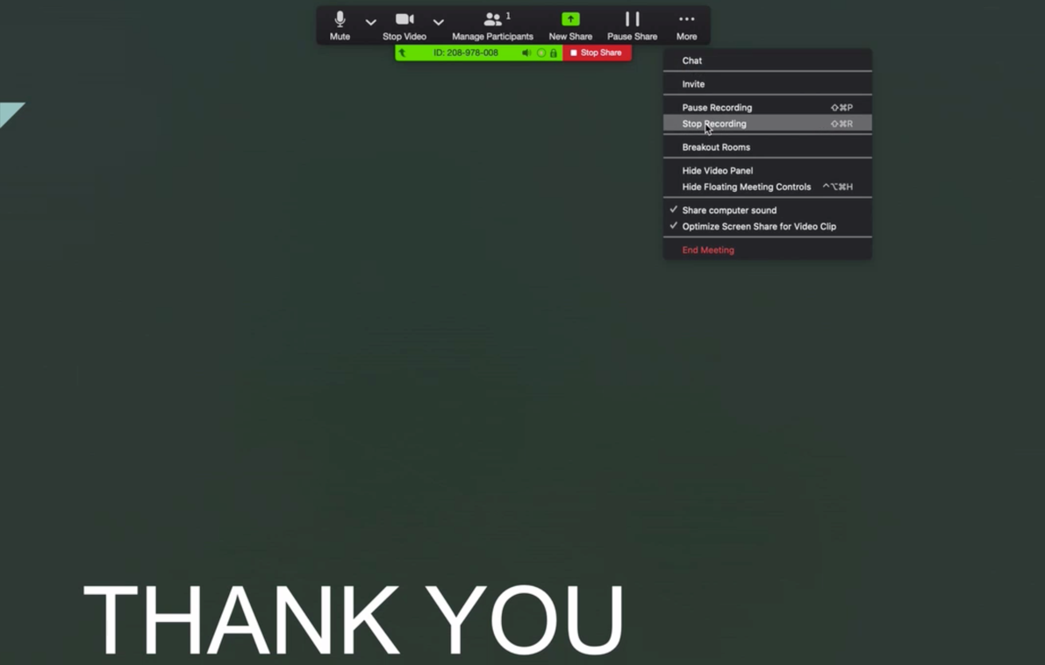

12. If you need to start another session or chunk of information in a new recording, you can do that by clicking Start Recording. That will start a new video recording without you having to stop the PowerPoint and without having to end the zoom meeting.

13. When you are completely done recording, select “End Meeting” at the bottom right corner of your screen. Then you’ll see that the zoom meeting is converting or processing.

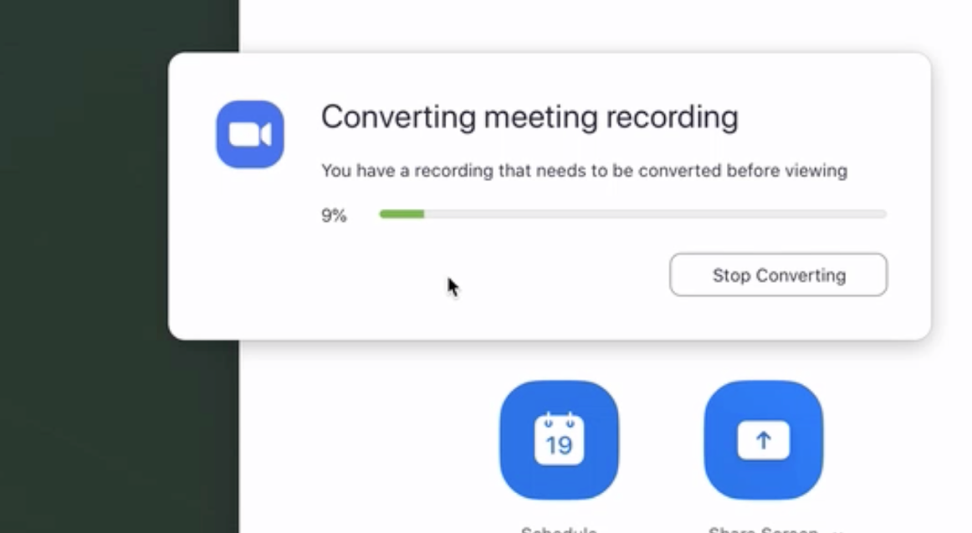

14. You will get an email link to your recording if you recorded to the cloud. You can forward that email to whomever is responsible for uploading those videos to Mediasite. It will help them if you will recommend a name for your file. The naming structure in Mediasite is:
- Course Prefix.CourseNumber.Name of Session
- i.e. MEDE.7555.Intro to GI diseases 2021

