Zoom Scheduled Meeting Invite
Schedule a meeting either on the Web in My Meetings or through the application directly.
App Invitation
- Log in to the Zoom application.
- Click Meetings.
- Select the meeting that you want to invite others to. Click Copy Invitation.
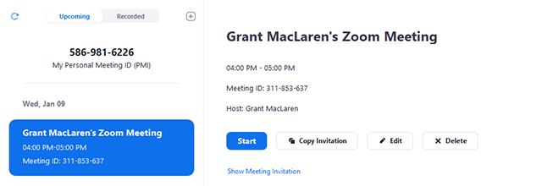The meeting invitation will be copied and you can paste that information into an email or anywhere else you would like to send it out.
Web Invitation
- Login to the My Meetings.
- Click on the topic of your meeting.
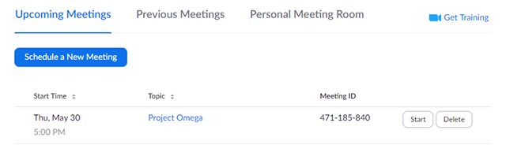
- Next to Time, there are options for adding to your calendar.
  - If you click on Google Calendar or Yahoo Calendar, it will create a calendar event automatically in the specific email service you choose.
  - If you click on Outlook Calendar, this will generate a .ics file that you import to your Outlook calendar.
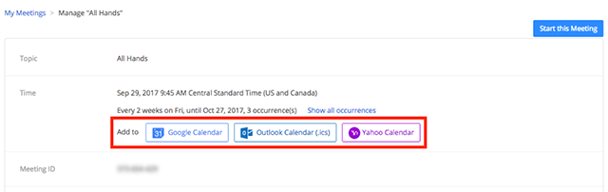
- You can also manually copy the meeting information by clicking the text that says Copy the invitation.
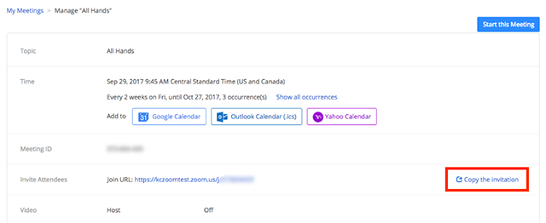
  - If you click on Copy the Invitation, another window will open with the meeting invitation text.
  - Click Select All.
  - You can copy the invitation and send it out through email or elsewhere.
